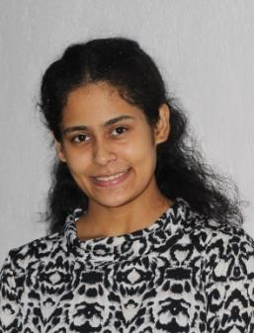


Tejashree Jena

 : Plot no-89/A, Kalpana Area, BJB Nagar,
Bhubaneswar,
Odisha,751014
: +91-6371112657
: tejashreejena12@gmail.com
Career Objective
To join an organization where I can utilize my technical and moral skills to add value to the organization and which will give me experience of corporate sector and will enhance my knowledge and get an opportunity to gain exposure expertise.

Education
Qualification | School / College | Board / University | Year of Passing | Percentage/ CGPA  Secured
BCA | UTKAL UNIVERSITY | Utkal University | 2023 | 85%
Higher Secondary | BUXI JAGABANDHU  ENGLISH  MEDIUM SCHOOL,  BHUBANESWAR | CBSE, ODISHA | 2020 | 65.4%
Secondary | BUXI JAGABANDHU  ENGLISH MEDIUM  SCHOOL,  BHUBANESWAR | CBSE,  ODISHA | 2018 | 83.6%
Strength
-Focused, Disciplined, Dependable and Optimistic
-Communication skills, Team-Work and Organizational skills
-Creative, Active Listener and Adapting
-Empathetic, Good Time Manager and Hard Working
Technical Skills
C, C++, HTML, SQL ,MS EXCEL, PHP, Python, Css
Hobbies and Interests
Painting
Crafting
Dancing
Personal Profile
Date of Birth | : 9th June ,2002
Gender | : Female
Father’s Name | : Tapas Kumar Jena
Mother’s Name | : Kalpana Jena
Marital Status | : Single
Conversant In | : English, Hindi, Odia
Address. | : Plot no-89/A, Kalpana Area, BJB Nagar, Bhubaneswar  PO: BJB Nagar, District: Khorda, State: Odisha,  PIN:751014
Alternate Phone No | : +91-9938163339
Declarations
I do hereby declare that all the statements mentioned above are correct to the best of my knowledge. I bear the responsibility for the correctness of the above-mentioned statements.
Place: Bhubaneswar Tejashree Jena

